**Reordering & Shipment-Based Purchase Order Management**

This document outlines the newly implemented features in your system that improve inventory restocking and purchase order management, especially for supplier-based operations and packing list imports.

# **Reordering Enhancements**

A new selection method has been added to control how product quantities are calculated during reordering. This method is configurable per product via a **new selection field** in the *Reordering* rule.

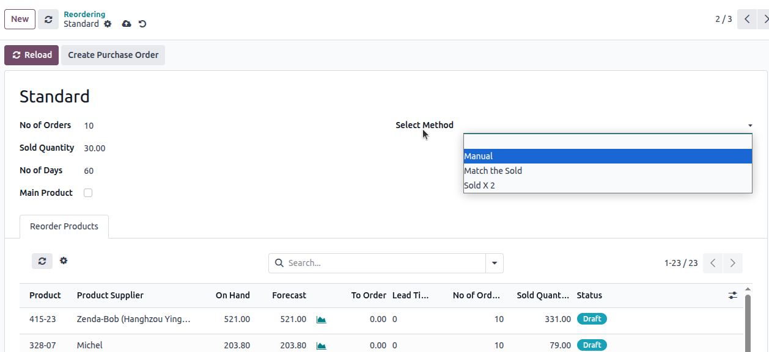

#### **1. Manual Reordering**

* When **Manual** is selected, two fields become visible:
  + Minimum Quantity
  + Maximum Quantity
* The system will reorder products based on the configured Min/Max values.

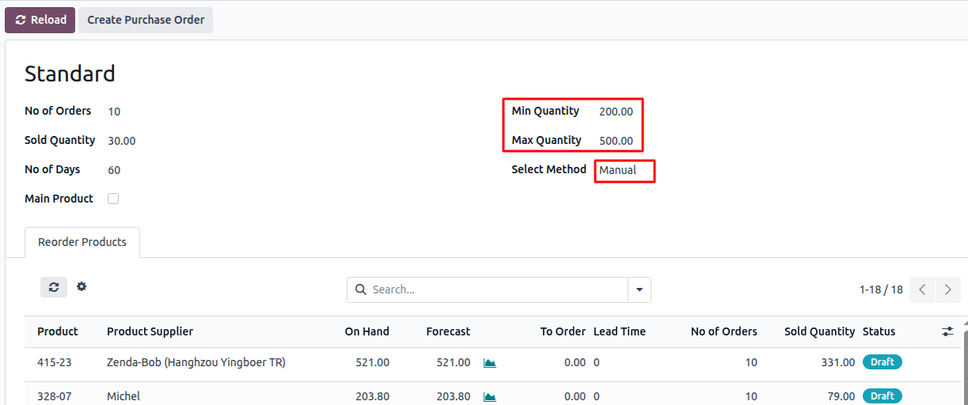

#### **2. Sold x 2**

* The system fetches the **total sold quantity** and **multiplies it by 2**.
* The result is used as the order quantity.

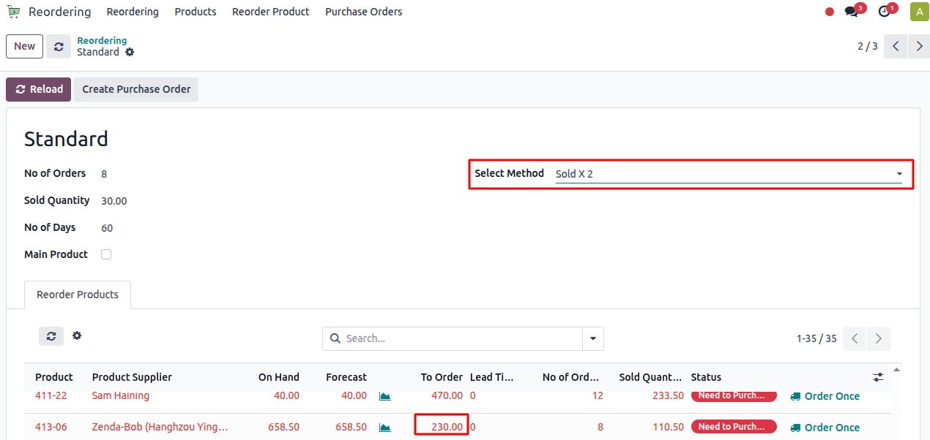

#### **3. Match the sold**

* The system compares:
  + Total sold qty
  + Current on-hand qty
* If the sold quantity is greater than on-hand, the **difference is reordered**.

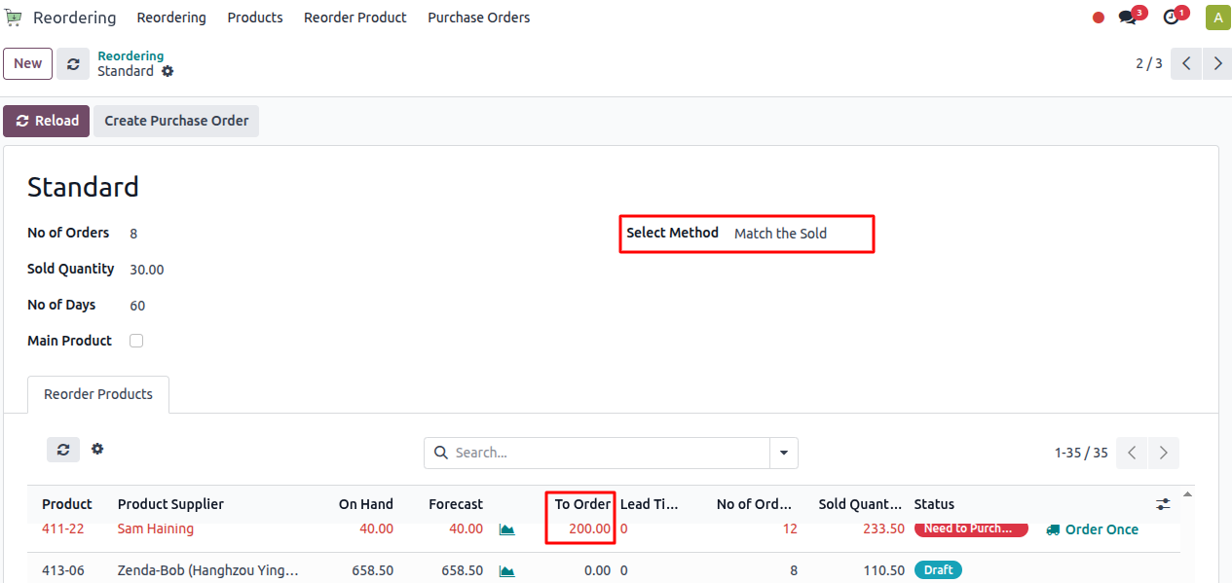

* If on-hand or forecast quantity is **greater than or equal to sold**, the **order quantity is set to 0**.

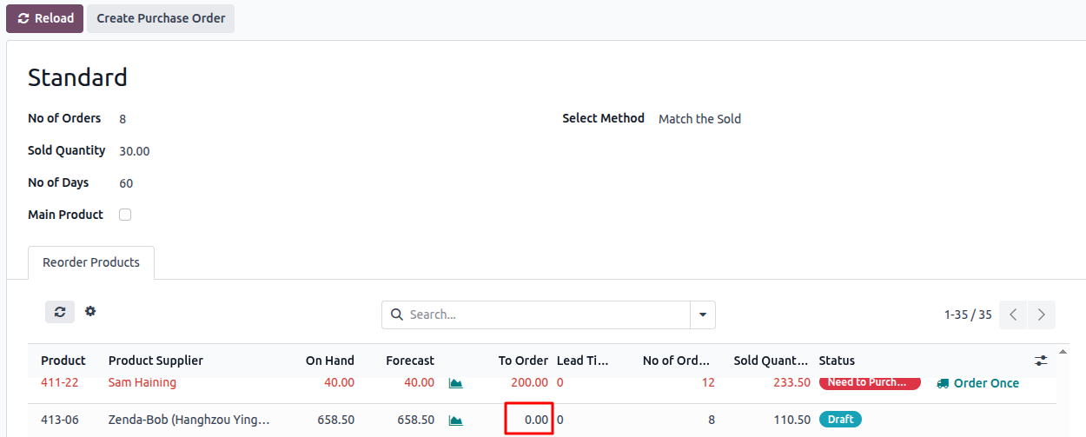

* **Special Case – Max Quantity Fallback**
  + For **all reordering methods**, if the **product itself** has a predefined **maximum quantity**, the system uses that product-level max quantity.

# **Reordering By Product Types**

* **A Product type** selection has been added to the reordering rule to allow users to filter products by **type** (e.g., All, Fabric, Blind Fabric, etc.).

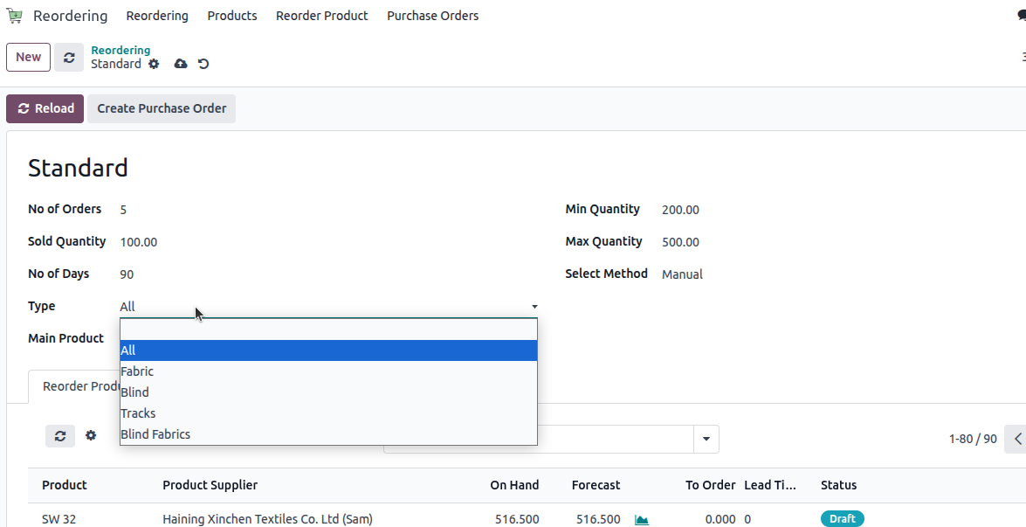

* By default, all products are loaded into the reordering lines.

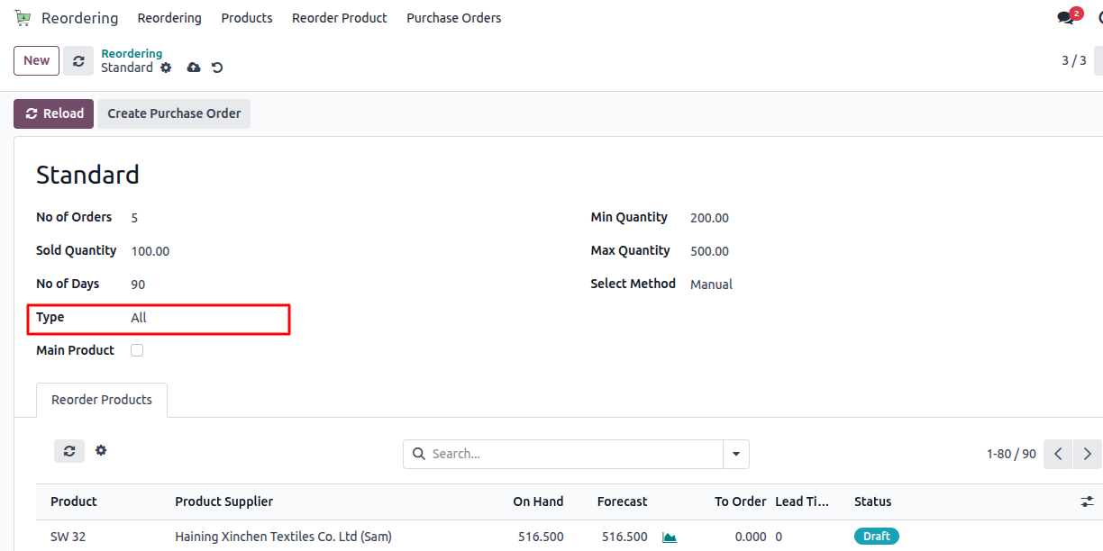

* When a specific type (e.g., Fabric) is selected, only products of that type are displayed and loaded into the reordering lines.
* Upon selection change, the list of products is reloaded based on the selected product type, ensuring the reordering interface shows only the relevant items.

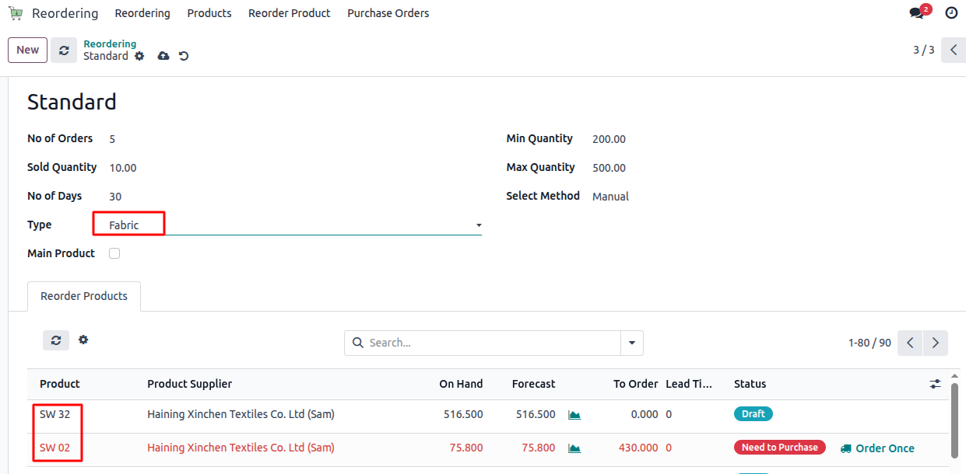

# **Shipment-Based Purchase Order Workflow**

* Create a purchase order from Product Reordering
* Navigate to the **Product Reordering Rules** menu.
* Click the **"Order Once"** button on the product that needs to be ordered.
* The system automatically creates a **Purchase Order** based on the product and its configured supplier.

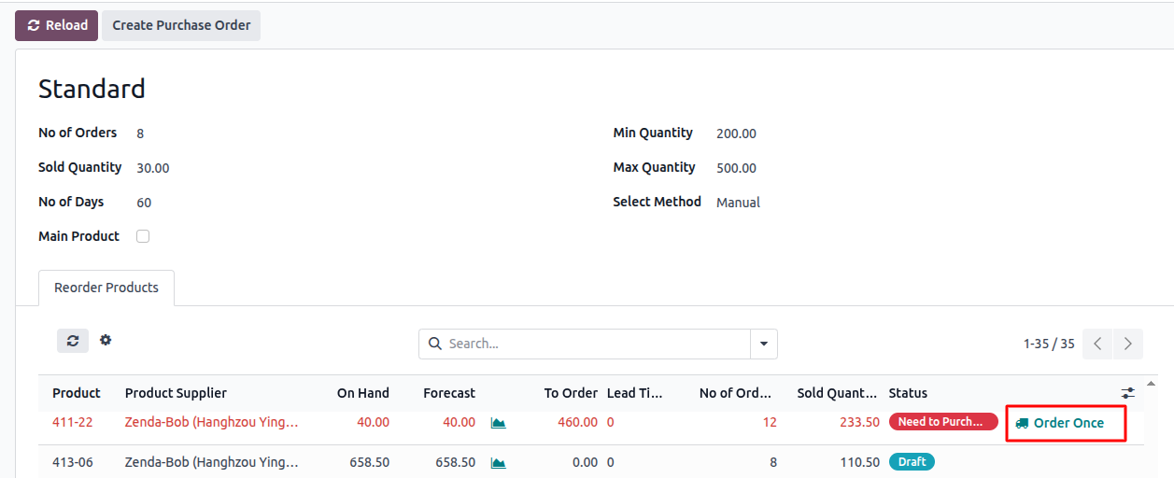

* Upon clicking the **"Create Purchase Order"** button, a new Purchase Order is generated **for products that require order from the reordering lines.**

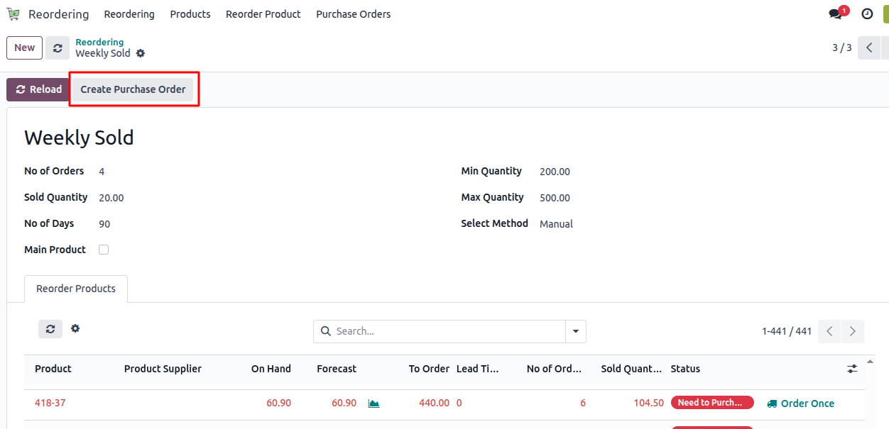

* The new Purchase Order is visible under the **Reordering** > **Purchase Orders** menu.

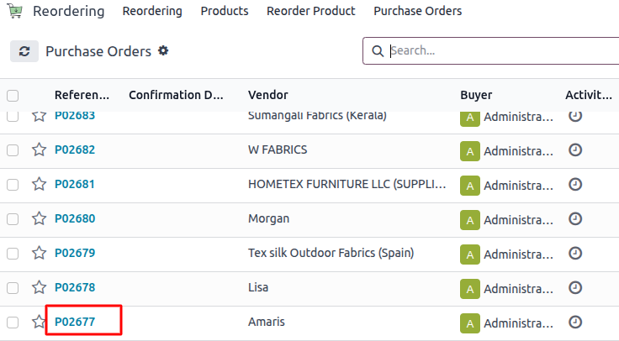

* Open the created Purchase Order.
* Click **"Import Packing List"** to import the product file.

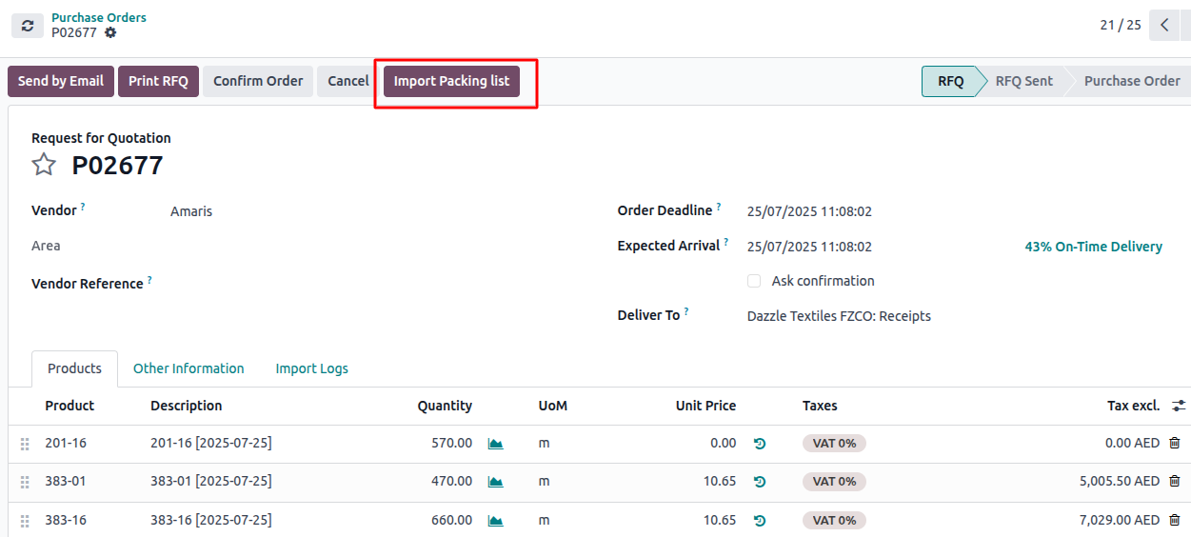

* Upload the Excel file and click **"Read"**.

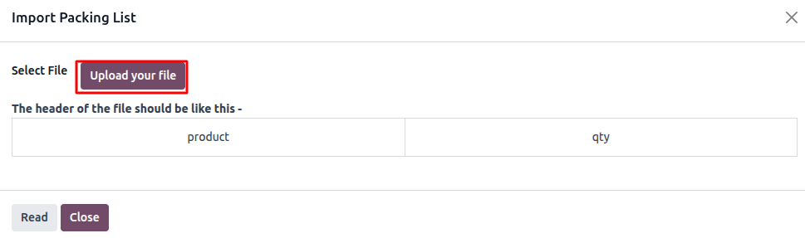

* **Excel should include columns like: product, qty**

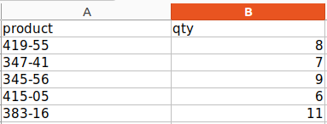

* The system reads the Excel and creates **Packing List Lines**.
* From the **packing lines**, users can **select specific products** that need to be added to a Purchase Order (PO).
* The **purchase order quantity** is updated based on the po quantity entered by the user from the packing line.

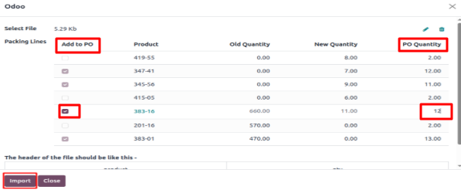

* It checks for each product whether to:
  + **Update** the current PO (if "Add to PO" is selected)
  + Or **move** the product to a **new draft PO** (if not selected)

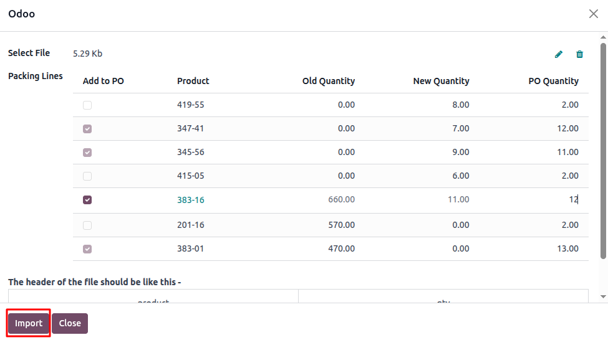

* If “Add to PO” is selected:
  + Product is added or updated in the **current PO**.
  + A **section line** is created referencing the **original purchase order**.

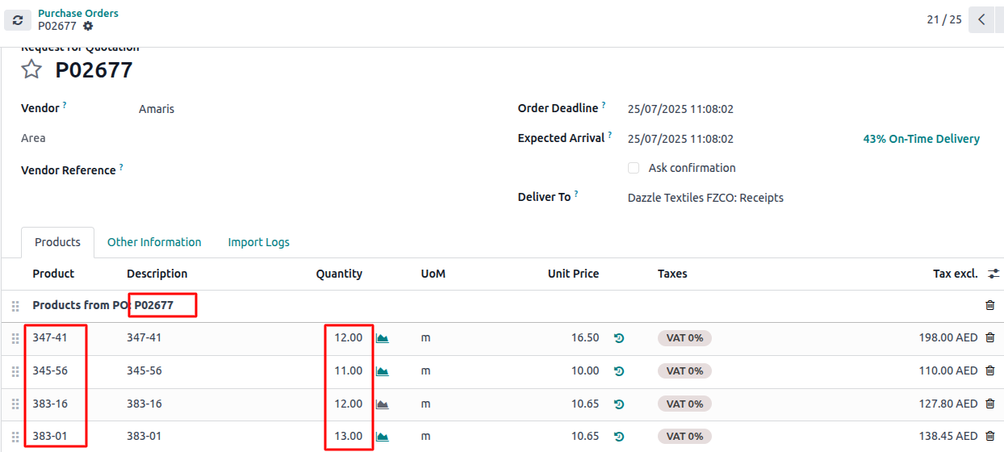

* If not selected:
  + Product is removed from the current PO (if already present).
  + A **new draft PO** is created with that product.
  + This draft PO is **linked to the original** via a reference.

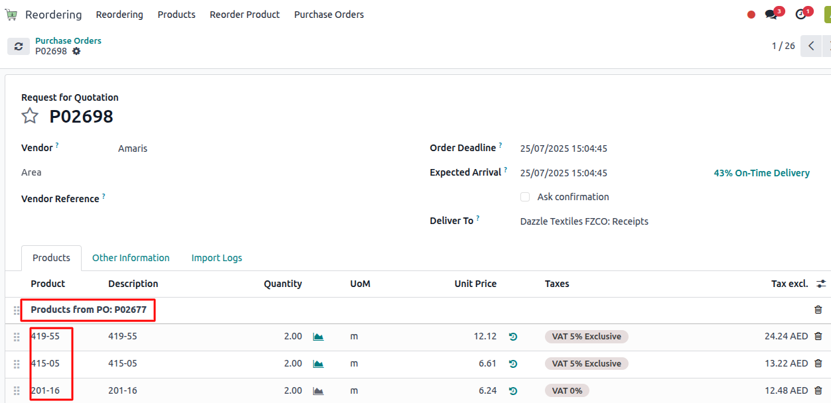

* Navigate to the **existing Purchase Order**.
* Click **"Import Packing List"** again.
* Upload the **Excel file** then Click **"Read File"** to process the data.

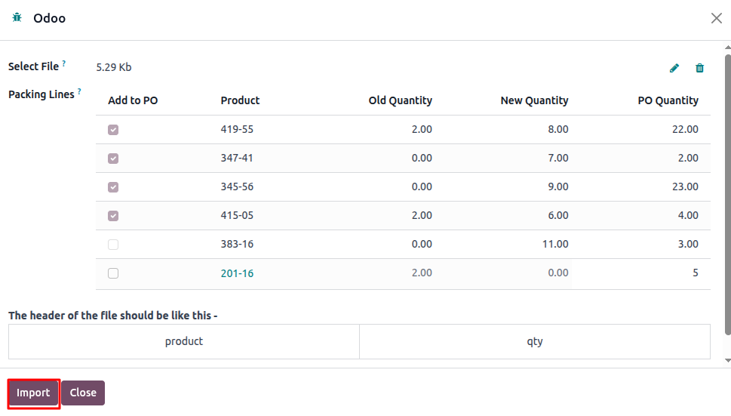

* You can re-import the packing list again as needed.
* All changes are tracked clearly through order references and section lines.